### **Student Feedback**

Ability to provide feedback to students and get feedback from Parents or Students.



Written By Venu Yarra

Updated 3 years ago

The system provides the ability to view & manage the Feedback of the Student.

Click on the Students menu and Students Info sub-menu to navigate to the Students info page. Double-click on the row of a Student you want to manage Feedback for a Student.

Clicking on the Feedback tab shows the list of Courses & Levels that are assigned to the Student. The staff can add the feedback of the Student for the corresponding class by clicking on the "Add Feedback" button in the "Feedback from Center" column.

Contacts or Students can also provide their feedback regarding the Class or Staff by clicking on the "Add Feedback" button in the "Feedback by Contact/Student" column. Note that the Staff can't see the "Add Feedback" button in the Feedback by Contact/Student column and Contacts or Students can't see the "Add Feedback" button in the Feedback by Staff column.

Contact us at lcmcoach@calimatic.com for any questions.

### **Add Or Manage A Student**

Add or Manage a Student from the Students Information Page



Written By Venu Yarra

Updated 3 years ago

Students Info Page is the place where you can manage all the student's information in a single location. The system maintains the consolidated information of the Students & their Contacts.

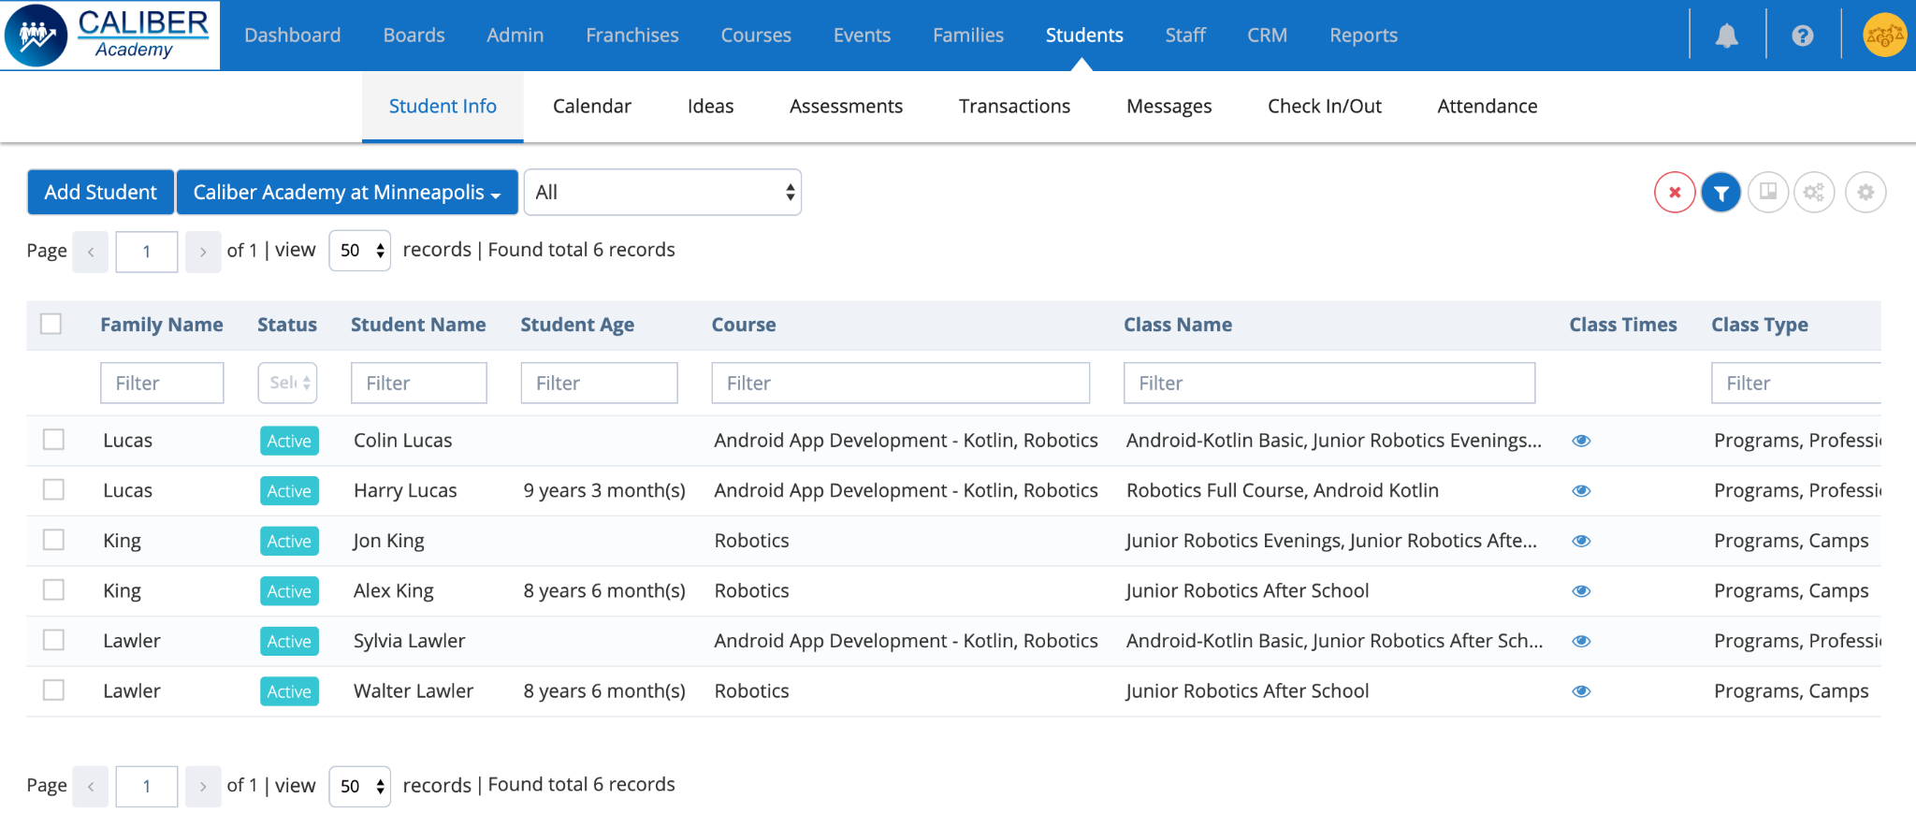

Click on the Students menu and Students Info sub-menu to navigate to the Students info page.

Any Class or Event enrollments made from the enrollment pages will add the Students in the grid.

You have the ability to directly add a Student here. Any Staff except Parent and Student can add & remove a Student based on the assigned permissions.

The Franchise is selected by default for the Franchise Accounts. Business Account users have the ability to filter the Students list with one or more Franchises.

Click on the “Add Student" button to add a new Student.

In the Overview tab, you have the ability to add Student's Information, add one or more Contacts of a Student.

You have the ability to set a Student to In-Active Status. Setting a Student to In-Active will move the Student to the Leads file. You also have the ability to set the Contact of a Student to Active or In-Active.

You can send Portal access to the Student or Contact by clicking on Action and “Send Portal Access" option. If the portal access is already created then you will not see this option.

The rest of the tabs in the popup will be enabled once you create a Student. All the information of a Student is managed in this popup across these tabs. The information can be viewed, added or edited by different roles based on the permissions. Example - Contacts and Students can set a Student to Active or In-Active.

Contact us at lcmcoach@calimatic.com for any questions.

### **Add Or Manage A Student**

Add or Manage a Student from the Students Information Page



Written By Venu Yarra

Updated 3 years ago

Students Info Page is the place where you can manage all the student's information in a single location. The system maintains the consolidated information of the Students & their Contacts.



Click on the Students menu and Students Info sub-menu to navigate to the Students info page.

Any Class or Event enrollments made from the enrollment pages will add the Students in the grid.

You have the ability to directly add a Student here. Any Staff except Parent and Student can add & remove a Student based on the assigned permissions.

The Franchise is selected by default for the Franchise Accounts. Business Account users have the ability to filter the Students list with one or more Franchises.

Click on the “Add Student" button to add a new Student.

In the Overview tab, you have the ability to add Student's Information, add one or more Contacts of a Student.

You have the ability to set a Student to In-Active Status. Setting a Student to In-Active will move the Student to the Leads file. You also have the ability to set the Contact of a Student to Active or In-Active.

You can send Portal access to the Student or Contact by clicking on Action and “Send Portal Access" option. If the portal access is already created then you will not see this option.

The rest of the tabs in the popup will be enabled once you create a Student. All the information of a Student is managed in this popup across these tabs. The information can be viewed, added or edited by different roles based on the permissions. Example - Contacts and Students can set a Student to Active or In-Active.

Contact us at lcmcoach@calimatic.com for any questions.

### **Student Classes**

Add Student to the Classes, Transfer or Drop from the Classes.



Written By Venu Yarra

Updated 3 years ago

The system provides the ability to add a Student to a Class within the portal apart from the regular enrollment process.

Click on the Students menu and Students Info sub-menu to navigate to the Students info page.

Double-click on the row of a Student you want to add a Student to the Class.

Clicking on the Classes tab shows the information of Classes that are added to the Student. Each Student of a Family is displayed in each section with their assigned classes. Click on the "Add to a Class"button to add a Student to a Class.

In the popup, hover & click "Add to the Class"button of a Course & Level you want the Student to be added. After you are done with adding the Student to all the Classes, click on the Close button to close the popup and view the Classes added to the Student. In the Student's grid, you will see the Class that you added.

In order to Drop Off the Student from a Class, click on the Drop Off option after clicking on the Actions button for the corresponding Class.

You can Drop Off the Student immediately or in the future date by selecting the required option in the popup. Clicking the "Yes" button will open a popup to confirm if you want the existing pending Challenges to be removed or keep them. Clicking on "Yes" will remove and drop off the Student from the Class. Clicking on "No" will keep the pending Challenges and drop off the Student from the Class.

In order to Transfer the Student from a Class to another Class, click on the Transfer option after clicking on the Actions button for the corresponding Class.

A list of currently enrolled classes will be displayed in the popup. Select the class from which you want the Student to be removed and click on the Continue button. Click on the Transfer button of the class to which you want the Student to be transferred to. Clicking the "Yes" button will open a popup to confirm if you want the existing pending Challenges to be removed or keep them. Clicking on "Yes" will remove and drop off the Student from the Class. Clicking on "No" will keep the pending Challenges and Transfer the Student to the Class.

You can also add the Student to a Class in Families Info Page under the Families menu.

The information can be viewed, added or edited by different roles based on the permissions. Example - Contacts and Students can't Drop or Transfer from a Class.

Contact us at lcmcoach@calimatic.com for any questions.

### **Student Medical Info**

Add or Manage Student's Medical Information



Written By Venu Yarra

Updated 3 years ago

The system provides the ability to add & manage the Medical information of the Student.

Click on the Students menu and Students Info sub-menu to navigate to the Students info page.

Double-click on the row of a Student you want to manage Medical Information for a Student.

Clicking on the Medical tab shows the Medical information of the Student.

Contact us at lcmcoach@calimatic.com for any questions.

### **Student Attendance**

Add, view or manage Student's Attendance



Written By Venu Yarra

Updated 3 years ago

The system provides the ability to view & manage the Attendance of the Student.

Click on the Students menu and Students Info sub-menu to navigate to the Students info page. Double-click on the row of a Student you want to manage Attendance for a Student.

Clicking on the Attendance tab shows the list of Classes that are assigned to the Student. For each Class, you have the ability to "View Attendance" and "Take Attendance" for the Student.

Clicking on the "View Attendance" button will display the list of all the Attendance marked.

Clicking on the "Take Attendance" button will display the list of all the timings of the Class for the next 1 month. You can filter the dates to filter the list. Clicking the "Attendance" button for the timing will give you the option to Submit Attendance for the Student for the corresponding timing

.

Clicking on the "Cancel Class" button for the timing will Cancel the Class. You can click on the Undo button to undo the class cancellation.

You have an option to add a Make-up/Unscheduled class by clicking on the â€œAdd Make-up/Unscheduled class". In the popup, provide the class details and click on Create to add the Make-up class.

You can also view & manage Attendance in multiple places like Attendance page under Families menu or Attendance page under the Students menu or in the Families popup of Families Info Page under the Families menu. The information can be viewed, added or edited by different roles based on the permissions. Example - Contacts and Students can't mark the attendance but can view it.

Contact us at lcmcoach@calimatic.com for any questions.

### **Student Communication**

Messages from and to Student



Written By Venu Yarra

Updated 3 years ago

The system provides the ability to send messages based on the permissions.

Click on the Students menu and Students Info sub-menu to navigate to the Students info page.

Double-click on the row of a Student you want to view & send messages.

Clicking on the Messages tab shows the list of Persons to whom the messages can be sent & viewed.

Staff can message the Family Contacts & Students and Family Contacts & Students can message the Staff. When you send a message to a person then a notification will appear in the notification area.

Certain Staff roles have the ability to send Group messages to a group of people.

Example - Admins can send a message to all the Staff or to All Contacts/Students.

Contacts and Students cannot send group messages.

Contact us at lcmcoach@calimatic.com for any questions.

### **Student Transactions**

View or Manage Transactions of a Student



Written By Venu Yarra

Updated 3 years ago

The system provides the ability to view and manage the Transactions of the Student.

Click on the Students menu and Students Info sub-menu to navigate to the Students info page. Double-click on the row of a Student you want to manage Transactions for a Student.

Clicking on the Transactions tab shows the list of Transactions that have been performed for the Student. All the paid payments will appear in this tab as Transactions.

If a single enrollment happens for multiple students for one or more classes then it is combined into a single transaction. If that enrollment has recurring payments then it is splitted into multiple payments which would be 1 payment per student for each recurring cycle.

In the grid, the

* **Original Amount** represents the Price of the Class.
* **Discount Amount** represents any Discount that is applied to the Class or any General Discount.
* **Class Fee Amount** represents the Class-specific Fees like registration Fee.
* **Total Amount** represents the amount that is calculated from the "**Original Amount plus Class Fee minus Discount Amount".**
* If the Payment is set to **Auto Deduct** then it is represented as Yes for the auto deduct.
* **Amount Paid** represents the Amount that has been paid.
* **Amount Refund** represents the Amount that has been refunded.
* **Balance** represents the balance amount that needs to be paid.
* **Paid Data & Time** information provides information on when the payment has been made.
* **Pay Method** represents the method by which the payment has been made.
* **Transaction key** represents the key by which the Transaction has been tracked.
* **Receipt** provides the link to the Receipt of the payment made.

Based on the Permissions, certain Staff roles can Refund the amount for any transaction. Note that the Refund can't be provided more than the amount paid for the transaction.

Contact us at lcmcoach@calimatic.com for any questions.

### **Student Billing Info**

Billing Information of a Student for Payments & Fees



Written By Venu Yarra

Updated 3 years ago

The system provides the ability to view and manage the Billing of the Student.

Click on the Students menu and Students Info sub-menu to navigate to the Students info page. Double-click on the row of a Student you want to manage Billing for a Student.

For Contacts and Students, Clicking on the Billing tab provides the ability to Add Billing details like adding a Credit Card information or linking a Bank Account. You also have the ability to make a particular method of payment as Primary and payments will be deducted from it. You can delete the Billing information but can't edit it as we don't store any billing information on file with us. All the Billing information is handled by the Stripe Payment Gateway.

Based on the Permissions, when certain Staff roles clicks on the Billing tab, the information about which account is the primary method of the payment is shown along with the information of “Method type", “Last 4 digits"and “When the Billing is Added".

Contact us at lcmcoach@calimatic.com for any questions.

### **Student Activity**

The activity of a Student like enrolling, transfer, drop-off, etc



Written By Venu Yarra

Updated 3 years ago

The system provides the ability to view the Activity of Student information.

Click on the Students menu and Students Info sub-menu to navigate to the Students info page. Double-click on the row of a Student you want to view the Activity for a Student.

Clicking on the Activity tab shows the list of Activities for the Student like Level Achieved, Course Completed, Student Added to a Class, etc. You have the ability to search for any of these activities.

Contact us at lcmcoach@calimatic.com for any questions.

### **Email A Student**

Email a Student or Student's Contact



Written By Venu Yarra

Updated 3 years ago

The system provides the ability to send an email to a Student.

Click on the Students menu and Students Info sub-menu to navigate to the Students info page. Double-click on the row of a Student you want to email.

Based on the permissions, you will see an Email icon in the top bar. Clicking on it will display a popup with the Student selected in the "Send Email to" field. In the Email Template field, you will have the ability to select an Email Template that is already designed. You have the ability to insert System values into the Email message by clicking on the Insert System Values link and selecting the variables. After you enter the Subject and Message and click on Send, then the email will be sent to the people selected in the "Send email to" field.

Contact us at lcmcoach@calimatic.com for any questions.

### **Student Payments**

Manage Payments and Fees for the Student



Written By Venu Yarra

Updated 3 years ago

The system provides the ability to view & manage the Payments of all the Students at one place. Note that only the Payments that are unpaid and scheduled payments will be listed here. Any Paid payments will be listed in the Transaction tab.

**Navigation:** Click on the Students main menu and Payments sub-menu to navigate to the Payments Page.



Following sections are displayed in the page -

1. **Enrollment Payments**

The Unpaid and Recurring payments are added in this section when a Student is enrolled or added to the class from the registration/enrollment page or from within the portal. This section is opened by default.

Refer to [Enrollment Payments Details](https://help-lcm.calimatic.com/article?categoryId=8&solutionId=122)

1. **Fee Payments**

The Assigned or Posted Fee payments that are Unpaid and Recurring for the Students are displayed in this section. This section is closed by default. Clicking on the section header will open the section.

Refer to [Fee Payments Details](https://help-lcm.calimatic.com/article?categoryId=8&solutionId=123)

Contact us at lmscoach@calimatic.com for any questions.

### **Students Payments - Fee Payments**

Manage the Fee Payments for Students



Written By Ivan Karmer

Updated 3 years ago

The Assigned or Posted Fee payments that are Unpaid and Recurring for the Students are displayed in the Fee Payments section.

**Navigation:** Click on the Students main menu and Payments sub-menu to navigate to the Payments Page. The Fee Payments section is closed by default. Clicking on the section header will open the section.



**Fee Payments details**

The system provides the ability to create different Fees (like Class Specific Fee, Material Fee, Transport Fee, etc) and assign them to the Students.

**Manage Fees**

Clicking on the “Manage Fee” button will display a popup to define & manage the Fees in one location. These Fees are not related to any enrollment payments and can be managed separately. Click on the “Add New” button to add any new Fee.

“Fee Name” - Specify the name of the Fee

“Fee Type” - The dropdown list displays the list of all the Fee Type. Click on the Manage button to add/manage Fee Types.

“Fee Start Date” - Specify the start date of the Fee. This is used to ensure any assigned Fee will be collected only after the set Start Date.

“Fee End Date” - Specify the End date of the Fee. This is used to ensure any assigned Fee will be collected only before the set End Date.

“Billing Cycle” - Specify the Billing Cycle (interval) of the Fee when the recurring is set.

“Auto Deduct” - Specify if the recurring Fee has to be deducted automatically or will be deducted manually.

“Orig. Amount” - Specify the Fee Amount that should be collected.

“Discount Type” - Specify the discount type (Number or Percentage) for the discount that will be applied for the Fee.

“Discount” - Specify the discount that will be applied for the Fee.

“Total Amount Due” - The total amount will be calculated from the (Original Amount - Discount).

“Note” - Specify any notes that provide any information about the Fees.

Clicking on the Save button will add the Fees to the grid in the Manage Fees popup. You have the ability update or delete the added Fees.

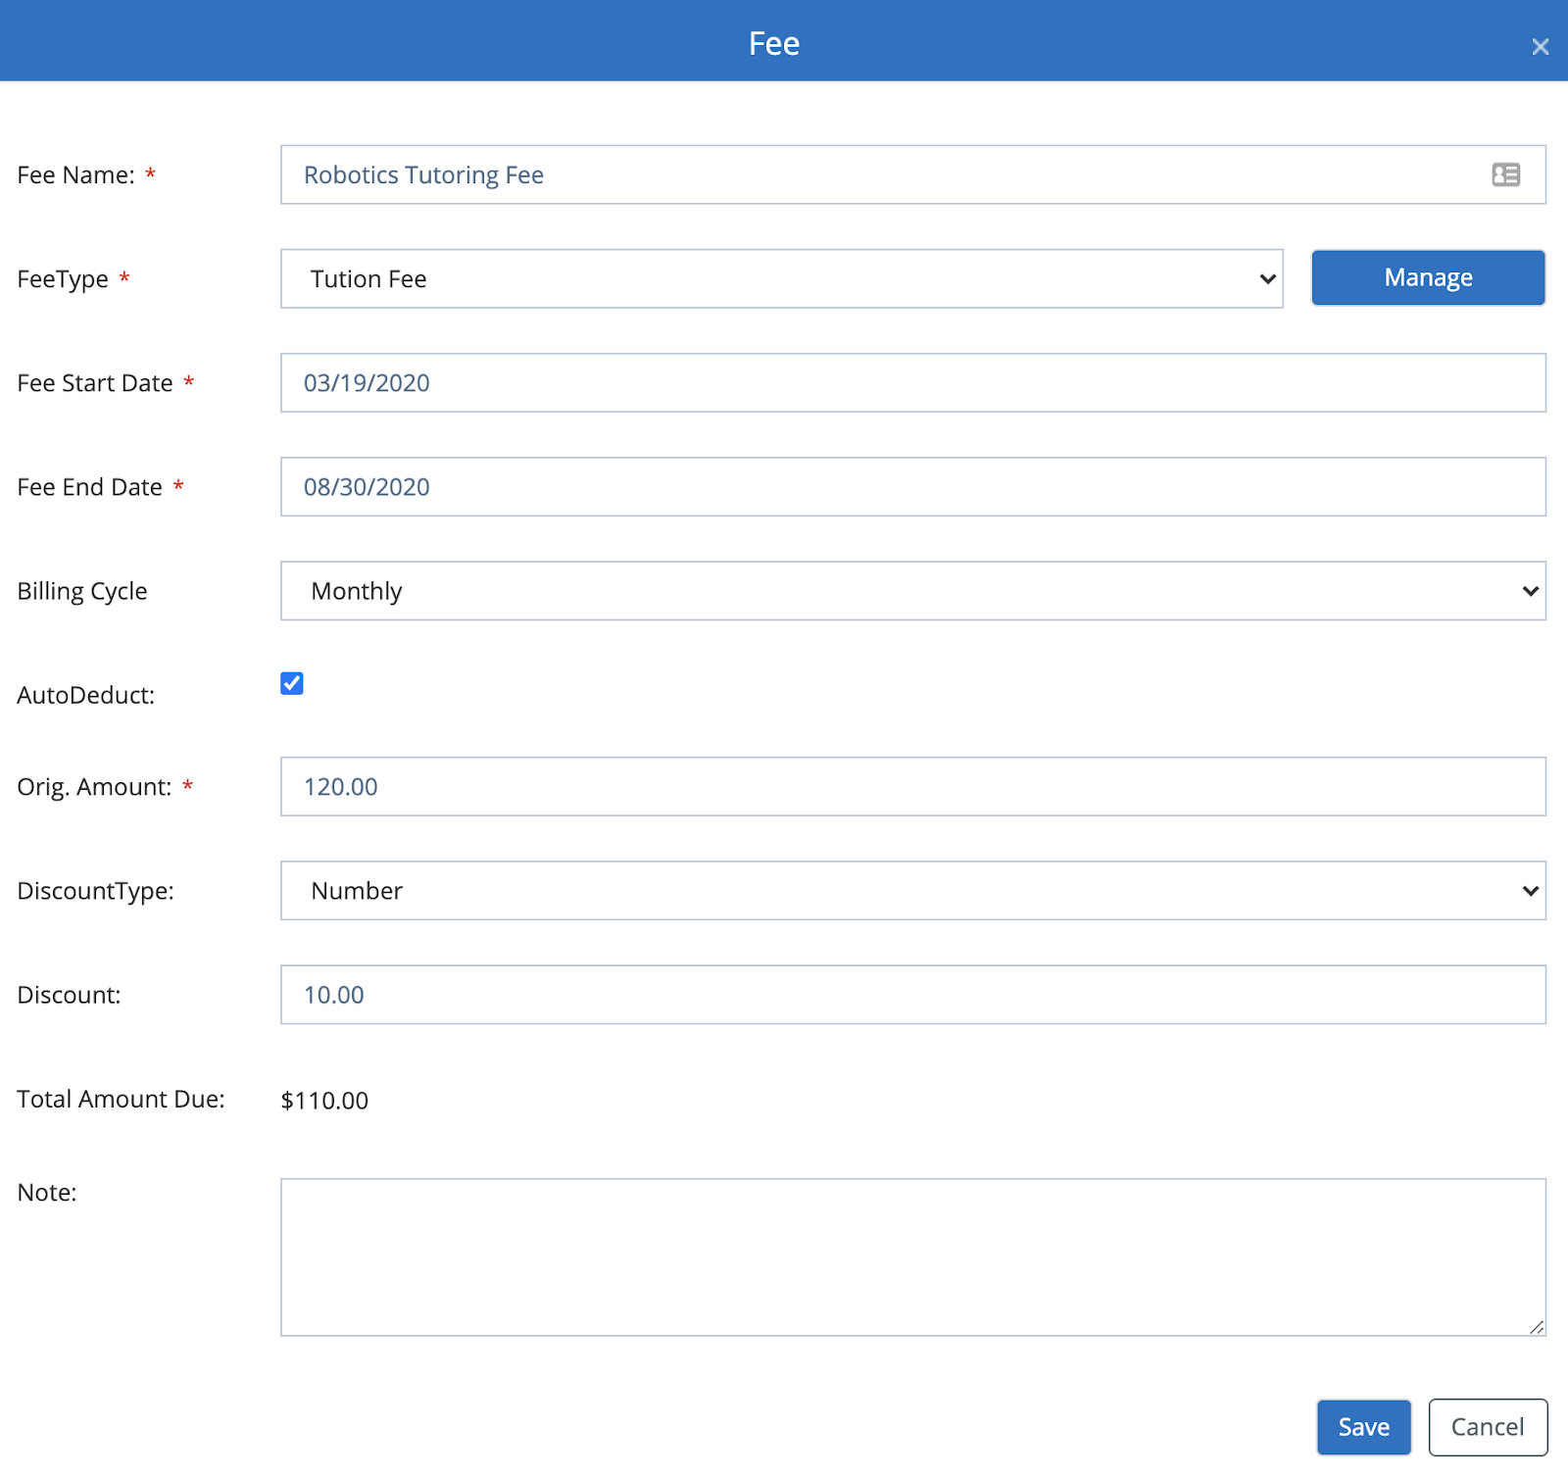

**Assign Fee**

Clicking on the “Assign Fee” button will display a popup to assign a Fee to one or more Students.

In the popup, select the Student(s) in the Student dropdown list. Select the Fee that needs to be applied to the selected student(s). Clicking on the Save button will apply the Fee to the selected Student(s).

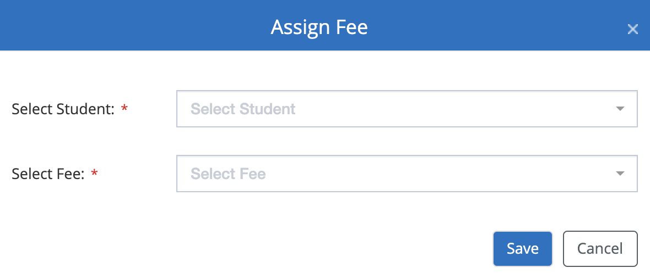

**Post Fee**

Clicking on the “Post Fee” button will display a popup to Post any Fee to a Family (all Students of the Family) or a Student.

In the popup, select the “Collect for a Family” or “Collect for a Student” option to collect the fee from a Family or only for a Student.

“Select Family” - If the Family option is selected then this field is displayed to select the Family.

“Select Student” - If the Student option is selected then this field is displayed to select the Student to whom the Fee needs to be applied.

“Fee Name” - Specify the name of the Fee that will be posted.

“Fee Type” - Specify the Type of the Fee that will be posted. You can add/manage the Fee Types in the current page > “Fee Payments” section > “Manage Fees” button > Manage button for Fee Types field.

“Fee Amount” - Specify the amount of the Fee that will be posted.

“Discount” - Specify the discount that will be deducted from the Fee.

“Total Amount” - The total amount will be calculated from the (Fee Amount - Discount).

“Note” - Specify any notes that provide any information about the Fees.

Clicking on the Collect button will collect the Fees directly if the Billing information is available on file. If there is no billing information then the Fees will be added to the grid.

Clicking on the Save button will add the Fees to the grid so that you can perform the actions on the Fee payment.

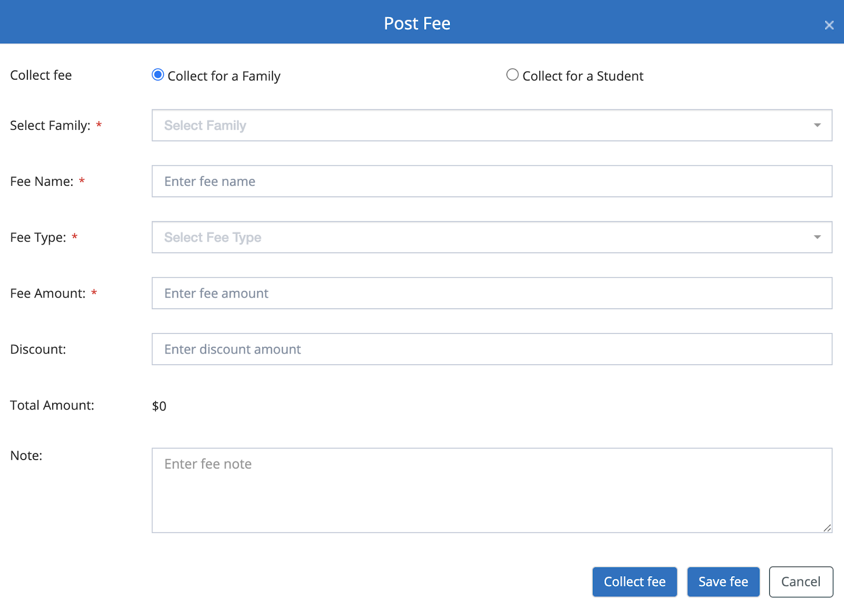

**Fee Payments grid**

In the grid “Student/Family” column represents the name of the enrolled student.

“Student Fee” column represents the Fee assigned to the Student.

“Orig Amt” column represents the original amount of the Fee.

“Disc Amt” column represents any Discount that is applied for the Fee and any General Discount.

“Total Amt” column represents the Amount that is calculated from (Fee - Discount).

“Billing Cycle” column represents the billing cycle of the recurring Fee. The payment will be deducted based on the specified interval.

“Status” column represents the Status of the Payment.

**Unpaid** status - Any assigned Fee that is not paid will be in the unpaid status.

**Scheduled Recurring** status - Any assigned Fee that is recurring, *is set to Auto Deduct* and scheduled for future payments will be in this status.

**Manual Recurring** status - Any assigned Fee that is recurring, is *NOT set to Auto Deduct* and scheduled for future payments will be in this status.

**Collect on Future Date** status - Any assigned Fee that is set to collect on the Future date will be in this status.

**Partially Hold** status - Any assigned Fee that is kept on Hold for a specific duration will be in this status.

**Cancelled** status - Any assigned Fee that is cancelled will be in this status.

“Next Scheduled Date” column represents the next billing date for the recurring payments.

“Auto Deduct” column represents the recurring payments that are set to deduct automatically. If it is marked as Yes then the system will automatically deduct.

If it is set to Manual then the payments need to be deducted manually by clicking on the Actions button, Recurring Payments option and clicking on the “Collect Payment” button for the corresponding payment.

Based on the assigned Permissions, certain Staff roles can perform actions for both Enrollment Payments and Fee payments. By default, Admins have permissions to provide all the actions.

Based on the payment status, you will see the following list of Actions when you hover on the grid row and click on the Action buttons -

**Pay -**

This option is displayed for the payments in Unpaid status to perform any pending payments. Clicking on the option will open a popup that will display the Balance amount and 3 options -

1. Send invoice Email for receiving payment

Selecting the option will provide the ability to send an invoice for receiving the payment.

1. Set the Payment Due - Specify the number of days by when the payment should be made.
2. Discount - Specify the Discount % or number (depending on the specified Discount type). The Total Amount Due will be changed based on the specified value.
3. Discount type - Specify the Discount type (Number or Percentage).
4. Total Amount Due - The total amount is calculated based on the balance and the discount.

Clicking on the “Send Invoice” will send an invoice email to the corresponding contact and/or student email id on file. The contact/student will have the ability to make the payment by clicking on the Pay button in their email. This will take them to the Stripe Payment page to make payment via Bank Account (US only) or Debit/Credit Card.

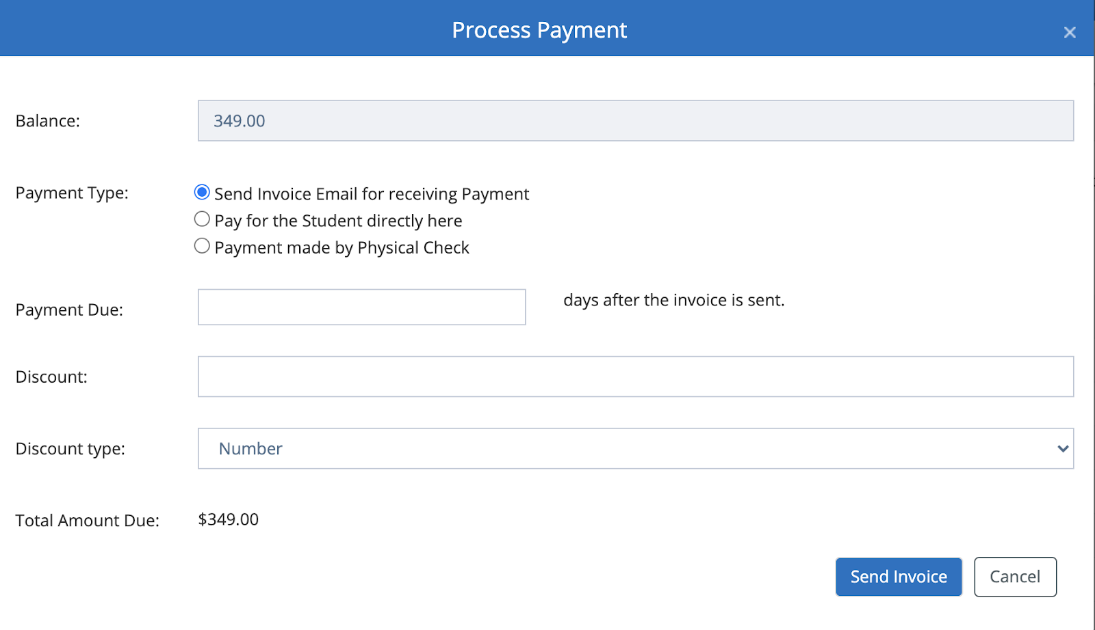

1. Pay for the Student directly here

Selecting the option will provide the ability to make the payment if the payment information is available from the Contact/Student.

1. Discount - Specify the Discount % or number (depending on the specified Discount type). The Total Amount Due will be changed based on the specified value.
2. Discount type - Specify the Discount type (Number or Percentage).
3. Total Amount Due - The total amount is calculated based on the balance and the discount.

If the billing information for the corresponding Student is available then clicking on Proceed button will collect the payment from the primary billing account.

If the billing information for the corresponding Student is NOT available then the system will prompt the popup to make the payment by entering the billing details.

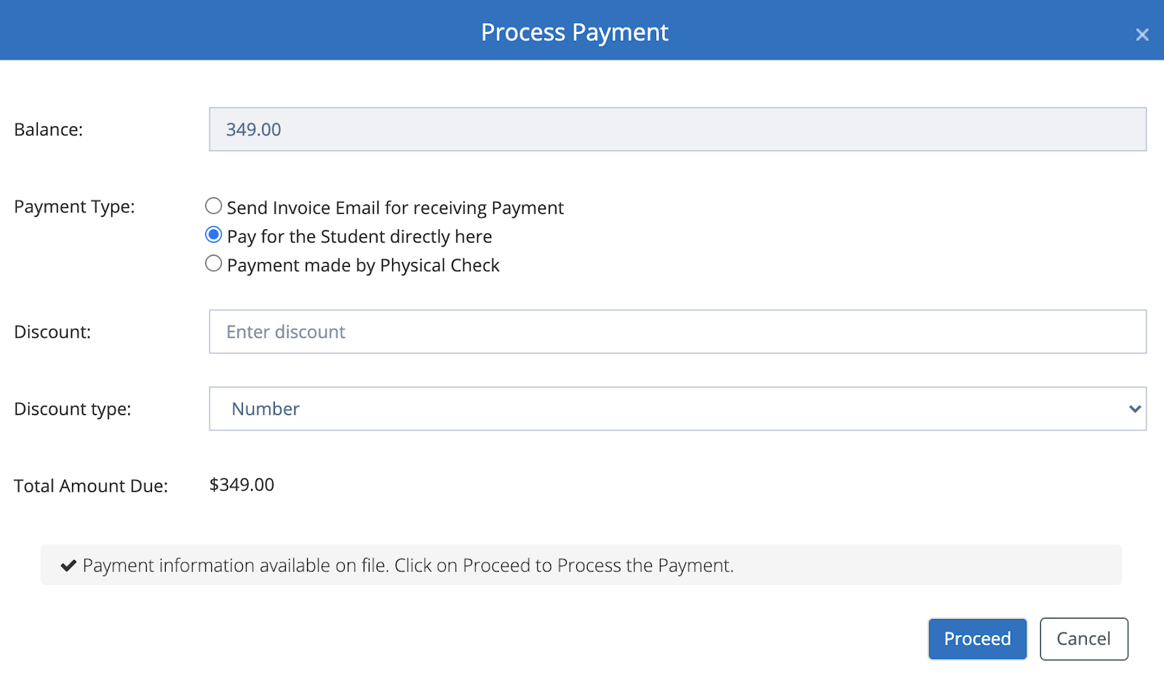

1. Payment made by Physical Check

Selecting the option will provide the ability to mark that the payment is made successfully for the balance by Check.

1. Amount Paid by Check - Specify the amount paid by check.
2. Remaining Balance - The balance is calculated from the Balance & the amount entered in “Amount Paid by Check” field.
3. Check Details - Specify the details of the Check and you can also add the check image if needed in the editor by clicking on the image icon and uploading the image.

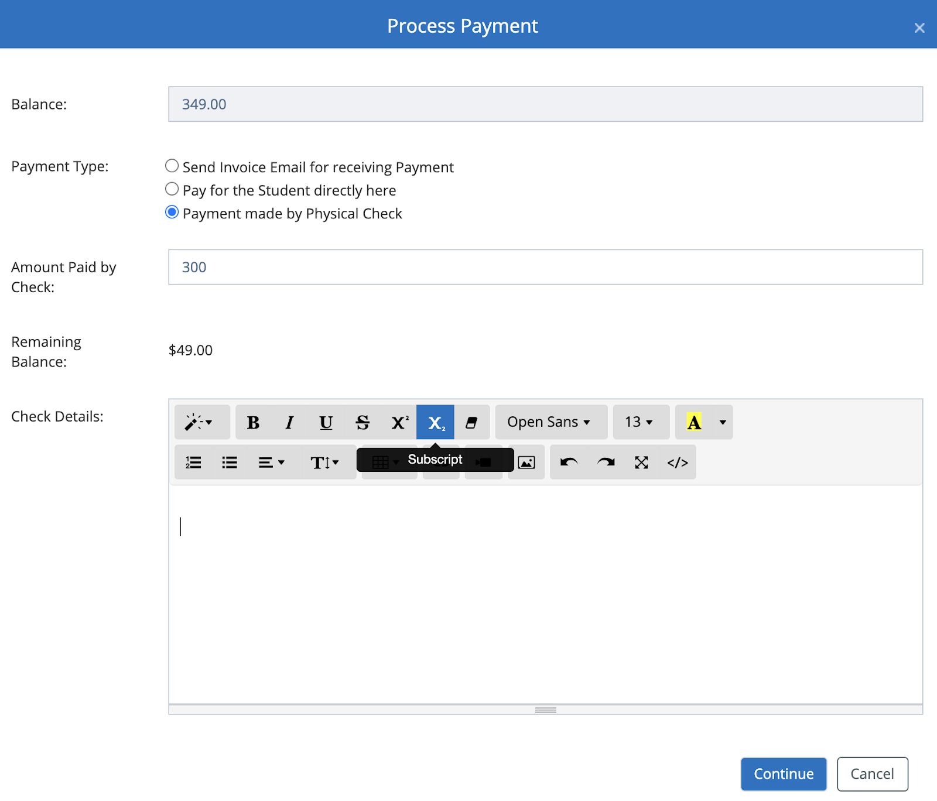

**Add/Update Future Collection Date**

Clicking on the option will provide the ability to schedule the Payment for a future date. In the popup, the Amount Due is displayed and provides the ability to set the Schedule Date for future.

Clicking on the Schedule button will set the schedule if there is billing information on file and change the status to “Collect on Future Date”.

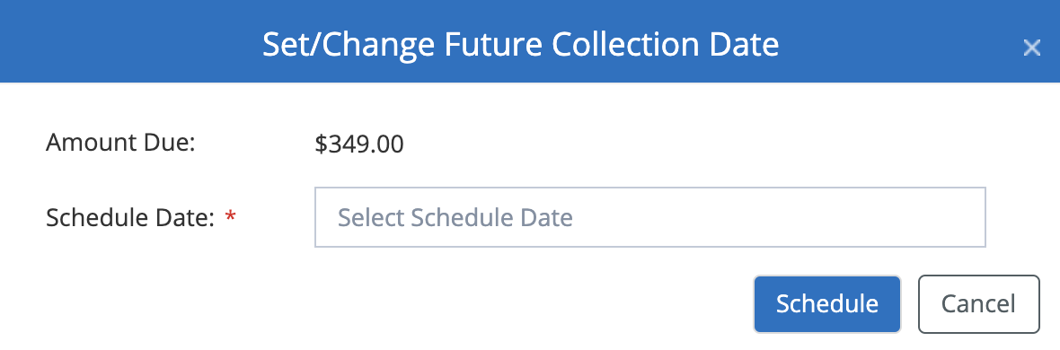

If the billing information is not found on file then the Schedule button will not be enabled to schedule.

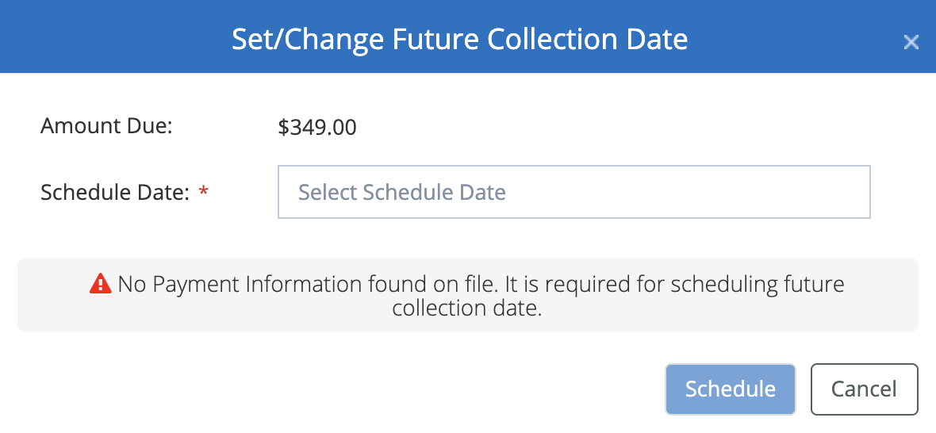

**Set/Change Recurring Date**

Clicking on the option will provide the ability to set the Recurring for the Payment. In the popup, you have the ability to set the Recurring Start Date, Recurring End Data, Recurring Billing Cycle (the payment interval on when the payments will be collected) and “Is Auto Deduct” (to deduct the payment automatically by the system or manually collect the payment).

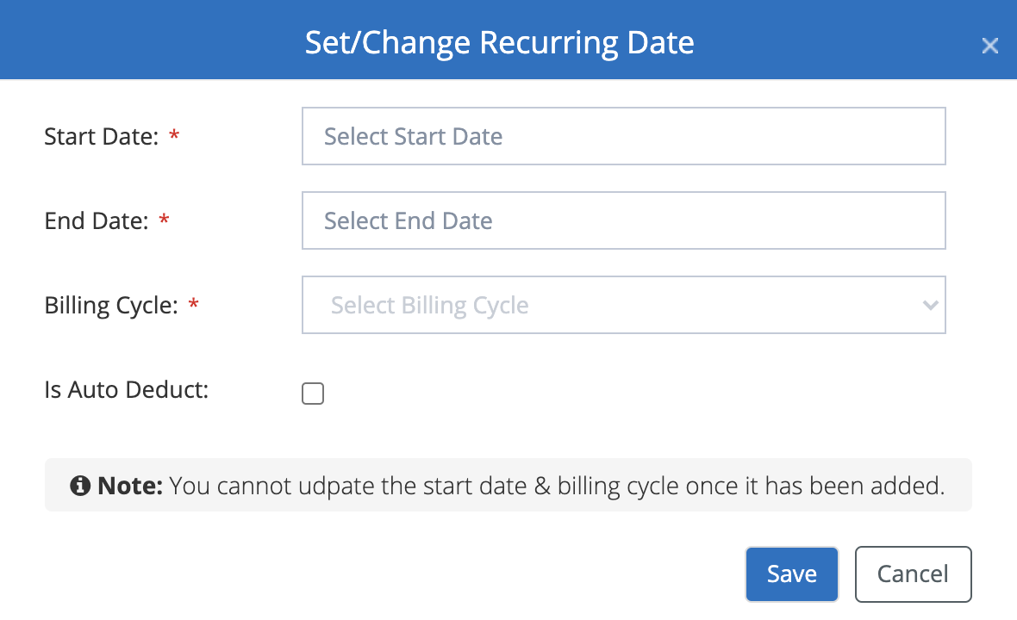

If the billing information is not found on file then the Save button will not be enabled to set the recurring.

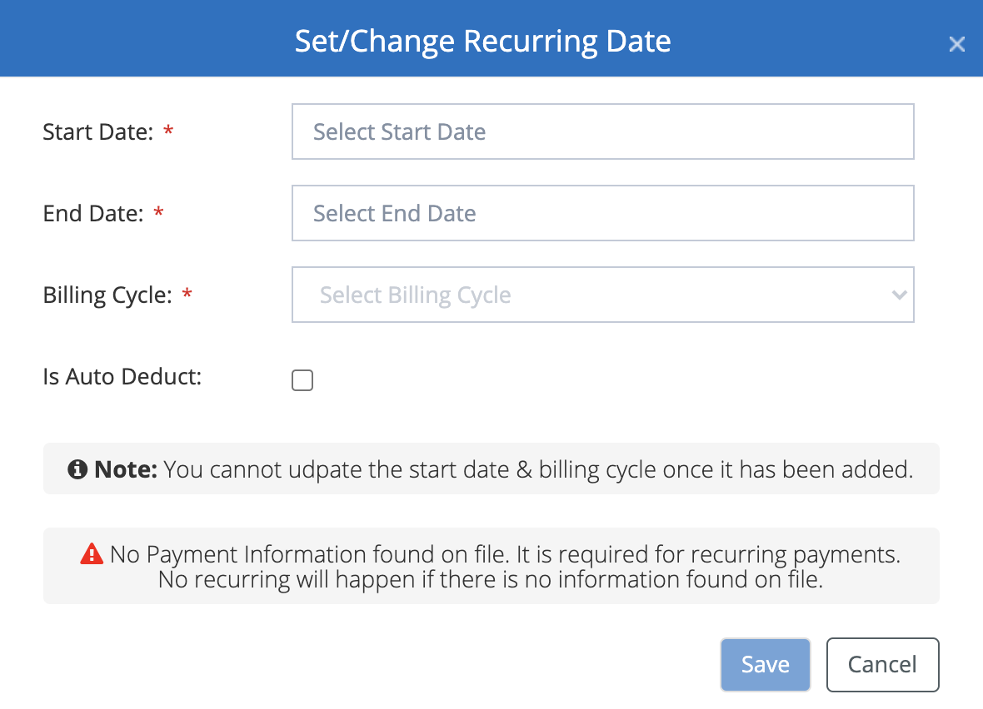

**Add/Update Coupon**

Clicking on the option will provide the ability to add or update a Coupon to apply any discount for the payment. In the popup, specify the Coupon code in the “Apply Coupon” field and click on the + button. The “Total Amount Due” is re-calculated after the coupon is applied and the applied coupon displays in the grid below. You have the ability to remove the coupon.

**Note:** The coupon codes can be defined in Admin > System Config > Manage Coupons page.

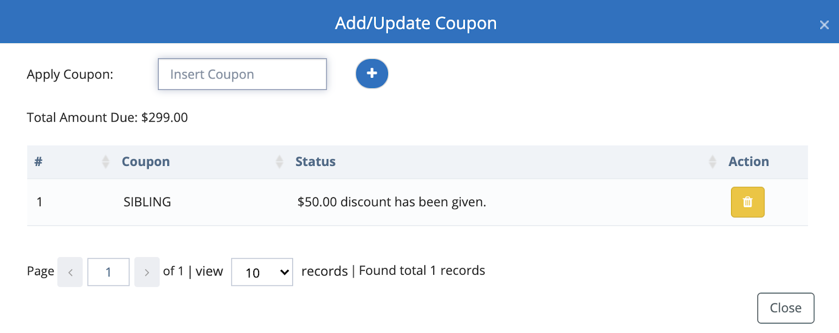

**Collect Payment**

Clicking on the option will provide the ability to collect any Adhoc (unscheduled) payments on a schedule date. In the popup, clicking on the “Add New” button will open a popup to enter the Adhoc payment Amount and the Collection Date (the date on when the payment should be collected). Clicking the Schedule button will add the Adhoc amount in the grid and the payments will be collected automatically from the billing account on file. If there is no billing account on file then the collection will not happen.

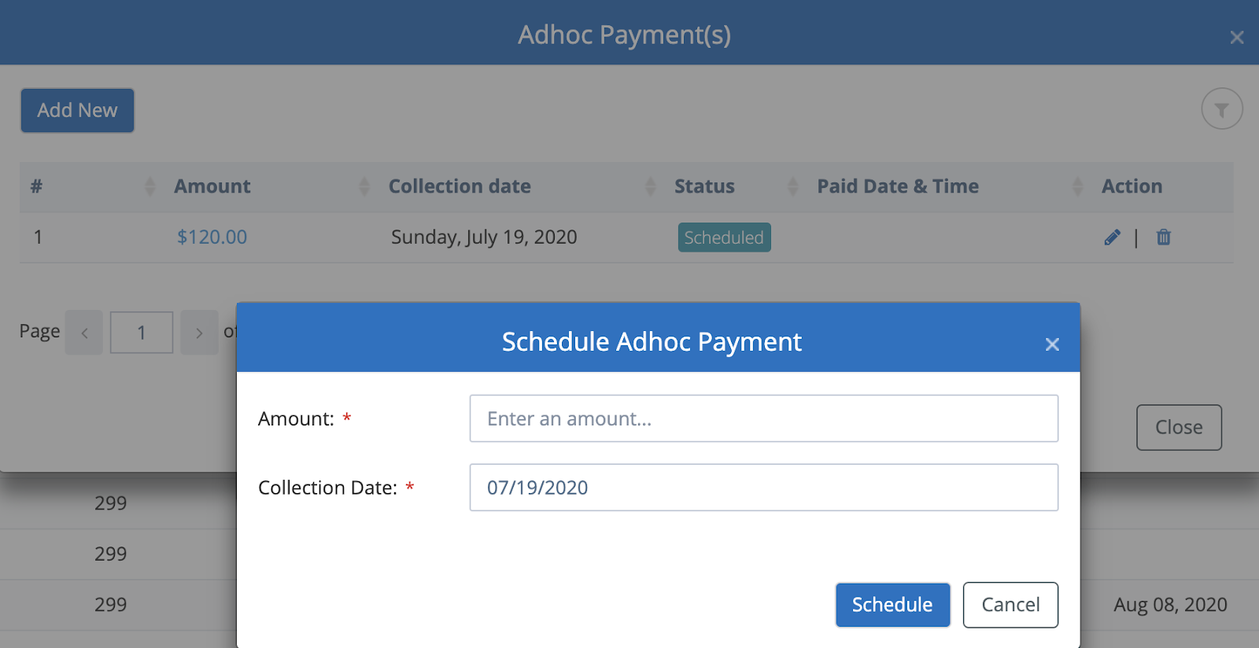

**Hold Payment**

Clicking on the option will provide the ability to Hold the corresponding recurring payment. In the popup, you have the ability to specify the Start and End Date. Clicking on the Hold will set the payment on hold for the specified duration. Any scheduled recurring payment will continue after the hold end date. For the payments that are set to hold will have the appropriated hold status.

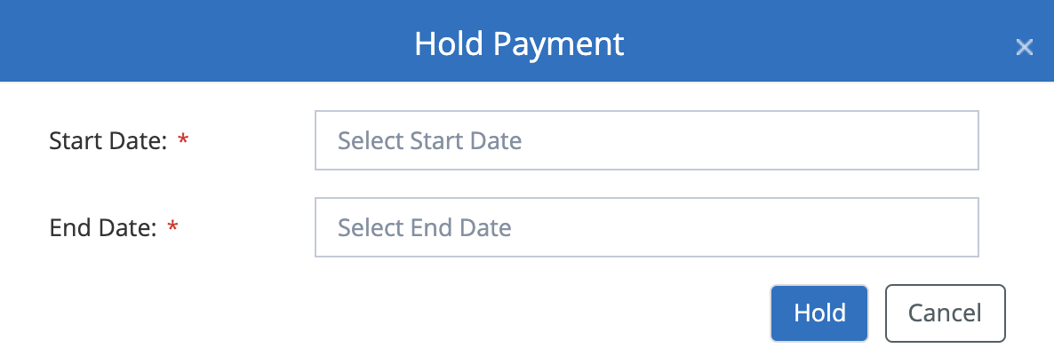

**Cancel Payment**

Clicking on the option will provide the ability to Cancel the corresponding recurring payment so that the payments will not occur any more. When the user clicks on Yes on the confirmation popup then the recurring payment will be set to Cancelled and any future recurring payments will not occur.

**Remove Payment**

Clicking on the option will provide the ability to Remove the corresponding payment so that the payment row will not appear anymore and any scheduled payments will not occur anymore once removed.

Contact us at lmscoach@calimatic.com for any questions.

### **Student Payments - Enrollment Payments**

Manage the Enrollment Payments for Students



Written By Ivan Karmer

Updated 3 years ago

The Unpaid and Recurring payments are added in the Enrollment Payments section when a Student is enrolled or added to the class from the registration/enrollment page or from within the portal. This section is opened by default.

**Navigation:** Click on the Students main menu and Payments sub-menu to navigate to the Payments Page.



**Enrollment Payments details**

In the grid “Student/Family” column represents the name of the enrolled student.

“Course Name” column represents the name of the enrolled course.

“Level” column represents the name of the enrolled level for the corresponding Course.

“Class” column represents the name of the class to which the Student is enrolled.

“Event Name” column represents the name of the enrolled Event.

“Event Timing” column represents the enrolled time of the Event.

“Orig Amt” column represents the Price amount of the Class.

“Disc Amt” column represents any Discount that is applied for the Class and any General Discount.

“Fee Amt” column represents the Class specific Fees like registration Fee, etc.

“Total Amt” column represents the Amount that is calculated from (Original Amount + Class Fee) - Discount Amount.

“Billing Cycle” column represents the billing cycle of the recurring payment. The payment will be deducted based on the specified interval.

“Status” column represents the Status of the Payment.

**Unpaid** status - Any enrollment or class payment that is not paid will be in the unpaid status.

**Scheduled Recurring** status - Any enrollment or class payment that is recurring, *is set to Auto Deduct* and scheduled for future payments will be in this status.

**Manual Recurring** status - Any enrollment or class payment that is recurring, is *NOT set to Auto Deduct* and scheduled for future payments will be in this status.

**Collect on Future Date** status - Any enrollment or class payment that is set to collect on the Future date will be in this status.

**Partially Hold** status - Any enrollment or class payment that is kept on Hold for a specific duration will be in this status.

**Cancelled** status - Any enrollment or class payment that is cancelled will be in this status.

“Next Scheduled Date” column represents the next billing date for the recurring payments.

“Auto Deduct” column represents the recurring payments that are set to deduct automatically. If it is marked as Yes then the system will automatically deduct.

If it is set to Manual then the payments need to be deducted manually by clicking on the Actions button, Recurring Payments option and clicking on the “Collect Payment” button for the corresponding payment.

“Requested by” column represents from where or whom the enrollment or adding the student to the class request came from.

Based on the assigned Permissions, certain Staff roles can perform actions for both Enrollment Payments and Fee payments. By default, Admins have permissions to provide all the actions.

Based on the payment status, you will see the following list of Actions when you hover on the grid row and click on the Action buttons -

**Pay -**

This option is displayed for the payments in Unpaid status to perform any pending payments. Clicking on the option will open a popup that will display the Balance amount and 3 options -

1. **Send invoice Email for receiving payment**

Selecting the option will provide the ability to send an invoice for receiving the payment.

1. Set the Payment Due - Specify the number of days by when the payment should be made.
2. Discount - Specify the Discount % or number (depending on the specified Discount type). The Total Amount Due will be changed based on the specified value.
3. Discount type - Specify the Discount type (Number or Percentage).
4. Total Amount Due - The total amount is calculated based on the balance and the discount.

Clicking on the “Send Invoice” will send an invoice email to the corresponding contact and/or student email id on file. The contact/student will have the ability to make the payment by clicking on the Pay button in their email. This will take them to the Stripe Payment page to make payment via Bank Account (US only) or Debit/Credit Card.



1. **Pay for the Student directly here**

Selecting the option will provide the ability to make the payment if the payment information is available from the Contact/Student.

1. Discount - Specify the Discount % or number (depending on the specified Discount type). The Total Amount Due will be changed based on the specified value.
2. Discount type - Specify the Discount type (Number or Percentage).
3. Total Amount Due - The total amount is calculated based on the balance and the discount.

If the billing information for the corresponding Student is available then clicking on Proceed button will collect the payment from the primary billing account.

If the billing information for the corresponding Student is not available then the system will prompt the popup to make the payment by entering the billing details.



1. **Payment made by Physical Check**

Selecting the option will provide the ability to mark that the payment is made successfully for the balance by Check.

1. Amount Paid by Check - Specify the amount paid by check.
2. Remaining Balance - The balance is calculated from the Balance & the amount entered in “Amount Paid by Check” field.
3. Check Details - Specify the details of the Check and you can also add the check image if needed in the editor by clicking on the image icon and uploading the image.



**Add/Update Future Collection Date**

Clicking on the option will provide the ability to schedule the Payment for a future date. In the popup, the Amount Due is displayed and provides the ability to set the Schedule Date for future.

Clicking on the Schedule button will set the schedule if there is billing information on file and change the status to “Collect on Future Date”.



If the billing information is not found on file then the Schedule button will not be enabled to schedule.



**Set/Change Recurring Date**

Clicking on the option will provide the ability to set the Recurring for the Payment. In the popup, you have the ability to set the Recurring Start Date, Recurring End Data, Recurring Billing Cycle (the payment interval on when the payments will be collected) and “Is Auto Deduct” (to deduct the payment automatically by the system or manually collect the payment).



If the billing information is not found on file then the Save button will not be enabled to set the recurring.



**Add/Update Coupon**

Clicking on the option will provide the ability to add or update a Coupon to apply any discount for the payment. In the popup, specify the Coupon code in the “Apply Coupon” field and click on the + button. The “Total Amount Due” is re-calculated after the coupon is applied and the applied coupon displays in the grid below. You have the ability to remove the coupon.

**Note:** The coupon codes can be defined in Admin > System Config > Manage Coupons page.



**Collect Payment**

Clicking on the option will provide the ability to collect any Adhoc (unscheduled) payments on a schedule date. In the popup, clicking on the “Add New” button will open a popup to enter the Adhoc payment Amount and the Collection Date (the date on when the payment should be collected). Clicking the Schedule button will add the Adhoc amount in the grid and the payments will be collected automatically from the billing account on file. If there is no billing account on file then the collection will not happen.



**Hold Payment**

Clicking on the option will provide the ability to Hold the corresponding recurring payment. In the popup, you have the ability to specify the Start and End Date. Clicking on the Hold will set the payment on hold for the specified duration. Any scheduled recurring payment will continue after the hold end date. For the payments that are set to hold will have the appropriated hold status.



**Cancel Payment**

Clicking on the option will provide the ability to Cancel the corresponding recurring payment so that the payments will not occur any more. When the user clicks on Yes on the confirmation popup then the recurring payment will be set to Cancelled and any future recurring payments will not occur.

**Remove Payment**

Clicking on the option will provide the ability to Remove the corresponding payment so that the payment row will not appear anymore and any scheduled payments will not occur anymore once removed.

Contact us at lmscoach@calimatic.com for any questions.